Plaza Heights Christian Academy
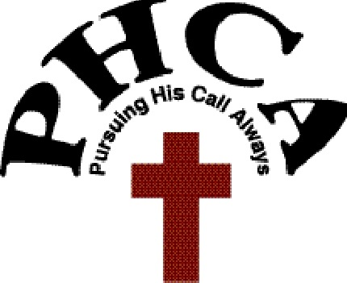
TUTOR LOG
A+ participants must perform a minimum of 50 hours of tutoring/mentoring prior to graduation. Tutoring/mentoring must be:

- Approved by the A+ Coordinator
- Performed within the PHCA community
- Documented on this log and verified by the signature of the supervisor

*Please note that forgery on this document will result in your removal from the A+ School Program.

________________________________________ __________________________________________
A+ Student Name (please print) Student Signature

___________________________________________________
PHCA A+ Coordinator Signature

DATE  mm/dd/yy | START TIME | END TIME | HOURS | WHERE | SUPERVISOR’S SIGNATURE
TOTAL HOURS

